**DEVOPS**

* **DevOps** is a collection of two words, “**Development**” and “**Operations”**.
* DevOps is a software development approach emphasizing collaboration, automation, and continuous delivery to provide high-quality products to customers quickly and efficiently.
* It shows cooperation between Development and Operations groups to deploy code to production quickly in an automated and repeatable manner.
* Every phase of the software development lifecycle, including planning, coding,

testing, deployment, and monitoring, is heavily automated in DevOps.

### **DevOps Lifecycle :**

The structure of the DevOps lifecycle consists of Plan, Code, Building, Test, Releasing, Deploying, Operating, and Monitoring.

* **Plan:**Determining the commercial needs and gathering the opinions of end-user by professionals in this level of the DevOps lifecycle.
* **Code:**At this level, the code for the same is developed and in order to simplify the design, the team of developers uses tools and extensions that take care of security problems.
* **Build:**After the coding part, programmers use various tools for the submission of the code to the common code source.
* **Test:**This level is very important to assure software integrity. Various sorts of tests are done such as user acceptability testing, safety testing, speed testing, and many more.
* **Release:**At this level, everything is ready to be deployed in the operational environment.
* **Deploy:**In this level, Infrastructure-as-Code assists in creating the operational infrastructure and subsequently publishes the build using various DevOps lifecycle tools.
* **Operate:**At this level, the available version is ready for users to use. Here, the department looks after the server configuration and deployment.
* **Monitor:**The observation is done at this level that depends on the data which is gathered from consumer behavior, the efficiency of applications, and from various other sources.

### **How DevOps Works?**

The DevOps Lifecycle divides the SDLC lifecycle into the following stages:

### **1. Continuous Development:**

This stage involves committing code to version control tools such as Git or SVN for maintaining the different versions of the code, and tools like Ant, Maven, Gradle for building/packaging the code into an executable file that can be forwarded to the QAs for testing.

### **2. Continuous Integration:**

The stage is a critical point in the whole DevOps Lifecycle. It deals with integrating the different stages of the DevOps lifecycle and is, therefore, the key in automating the whole DevOps Process.

### **3. Continuous Deployment:**

In this stage the code is built, the environment or the application is containerized and is pushed onto the desired server. The key processes in this stage are Configuration Management, Virtualization, and Containerization.

### **4.** **Continuous Testing:**

The stage deals with automated testing of the application pushed by the developer. If there is an error, the message is sent back to the integration tool, this tool, in turn, notifies the developer of the error, If the test was a success, the message is sent to Integration-tool which pushes the build on the production server.

### **5. Continuous Monitoring:**

The stage continuously monitors the deployed application for bugs or crashes. It can also be set up to collect user feedback. The collected data is then sent to the developers to improve the application.

# **DevOps Lifecycle:**

* **DevOps Lifecycle** is the set of phases that includes [DevOps](https://www.geeksforgeeks.org/introduction-to-devops/)for taking part in[Development](https://www.geeksforgeeks.org/web-development/)and Operation group duties for quicker software program delivery.
* DevOps follows positive techniques that consist of **code, building, testing, releasing, deploying, operating, displaying, and planning.**
* effortless to manipulate and it helps satisfactory delivery.

**7 Cs of DevOps**

1. Continuous Development
2. Continuous Integration
3. Continuous Testing
4. Continuous Deployment/Continuous Delivery
5. Continuous Monitoring
6. Continuous Feedback
7. Continuous Operations

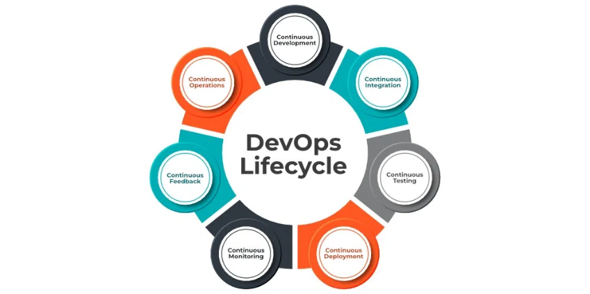

### **1. Continuous Development**

* In Continuous Development code is written in small, continuous bits rather than all at once,
* this improves efficiency every time a piece of code is created, it is tested, built, and deployed into production.
* Continuous Development raises the standard of the code and streamlines the process of repairing flaws, vulnerabilities, and defects.
* It facilitates developers’ ability to concentrate on creating high-quality code.

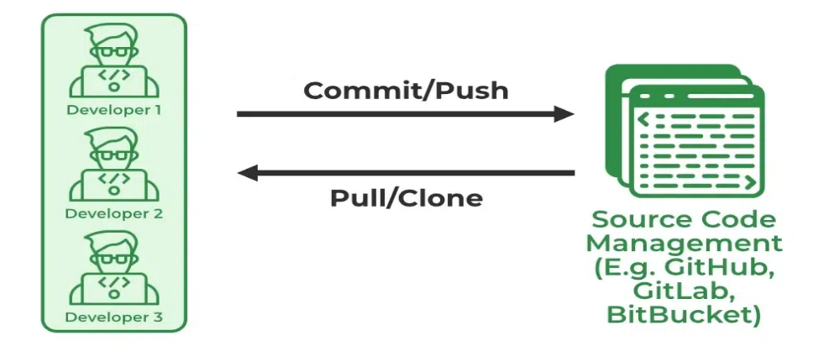

### **2.Continuous Integration**

Continuous Integration can be explained mainly in 4 stages in DevOps. They are as follows:

1. Getting the SourceCode from SCM
2. Building the code
3. Code quality review
4. Storing the build artifacts

* **source code management(SCM)** when the developer develops the code on his local machine he pushes it to the remote repository which is GitHub from here who is having the access can Pull, clone and can make required changes to the code.
* From there by using [**Maven**](https://www.geeksforgeeks.org/introduction-apache-maven-build-automation-tool-java-projects/)**we can build** them into the required package (war, jar, ear) and can test the Junit cases.
* [**SonarQube**](https://www.geeksforgeeks.org/software-testing-security-testing-tools/)**performs code quality reviews**where it will measure the quality of source code and generates a report in the form of HTML or PDF format.
* **Nexus for storing the build artifacts** will help us to store the [artifacts](https://www.geeksforgeeks.org/artifact-software-development/) that are build by using Maven and this whole process is achieved by using a Continuous Integration tool [Jenkins](https://www.geeksforgeeks.org/what-is-jenkins/).

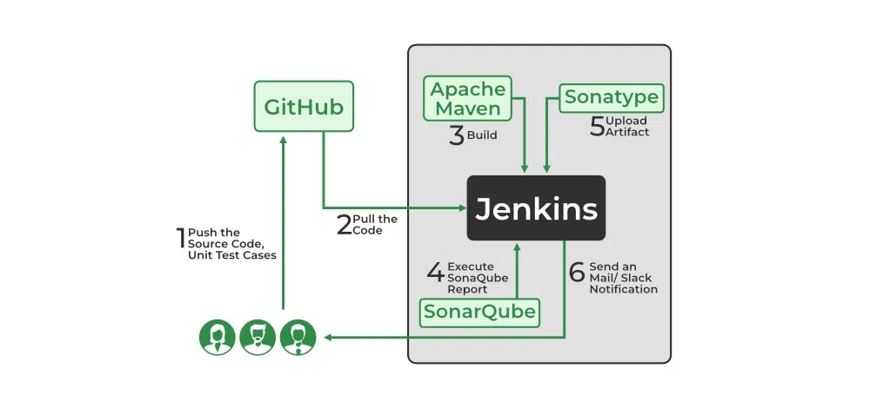

### **3. Continuous Testing**

* Any firm can deploy continuous testing with the use of the agile and DevOps methodologies.
* Depending on our needs, we can perform continuous testing using automation testing tools such as **Testsigma,**[**Selenium**](https://www.geeksforgeeks.org/selenium-basics-components-features-uses-and-limitations/)**, [LambdaTest](https://www.geeksforgeeks.org/tag/lambdatest/),**etc.
* With these tools, we can test our code and prevent problems and code smells, as well as test more quickly and intelligently.
* With the aid of a continuous integration platform like Jenkins, the entire process can be automated.

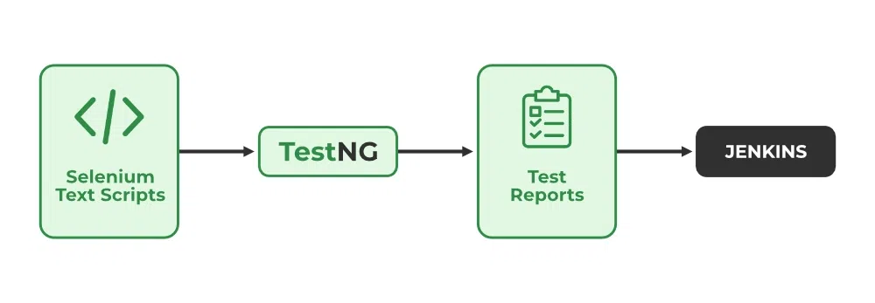

### **4.Continuous Deployment/ Continuous Delivery**

**Continuous Deployment:**

* [Continuous Deployment](https://www.geeksforgeeks.org/overview-of-continuous-deployment/)is the process of automatically deploying an application into the production environment when it has completed testing and the build stages.
* we’ll automate everything from obtaining the application’s source code to deploying it.

**Continuous Delivery:**

* [Continuous Delivery](https://www.geeksforgeeks.org/ci-cd-continuous-integration-and-continuous-delivery/) is the process of deploying an application into production servers manually when it has completed testing and the build stages.
* we’ll automate the continuous integration processes, however, manual involvement is still required for deploying it to the production environment.

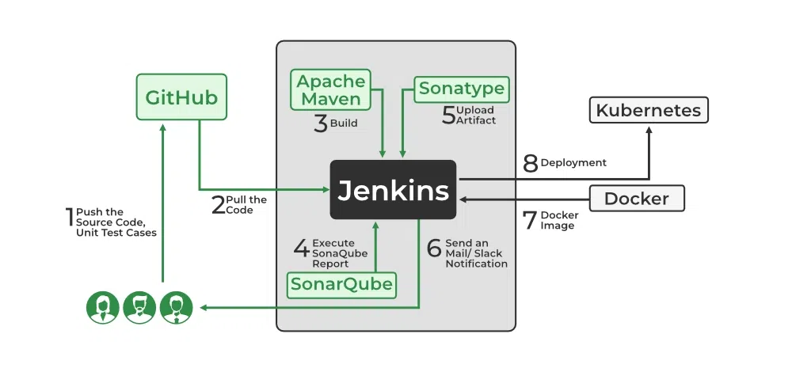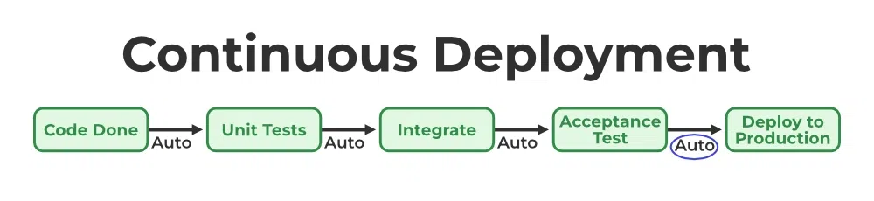

### **5. Continuous Monitoring**

* Continuous Monitoring can be achieved with the help of Prometheus and Grafana .
* we can continuously monitor and can get notified before anything goes wrong with the help of Prometheus we can gather many performance measures, including CPU and memory utilization, network traffic, application response times, error rates, and others.
* Grafana makes it possible to visually represent and keep track of data from time series, such as CPU and memory utilization.

### **6. Continuous Feedback**

* Once the application is released into the market the end users will use the application and they will give us feedback about the performance of the application and any glitches affecting the user experience.
* after getting multiple feedback from the end users’ the DevOps team will analyze the feedbacks given by end users and they will reach out to the developer team tries to rectify the mistakes they are performed in that piece of code.
* we can reduce the errors or bugs that which we are currently developing and can produce much more effective results for the end users.
* we reduce any unnecessary steps to deploy the application.
* Continuous Feedback can increase the performance of the application and reduce bugs in the code making it smooth for end users to use the application.

### **7. Continuous Operations**

* We will sustain the higher application uptime by implementing continuous operation, which will assist us to cut down on the maintenance downtime that will negatively impact end users’ experiences.
* More output, lower manufacturing costs, and better quality control are benefits of continuous operations.

**Concepts on which you have to focus on are:**

* Automation with CI/CD (Continuous Integration and Continuous Delivery) tools like TeamCity and Jenkins
* Deployment tools like Ansible and Docker
* Kubernetes and Containerization
* AWS
* Cloud Computing
* Linux fundamentals
* Server configuration management
* Coding (Perl, Ruby, Python) and Testing
* Hands-on Cloud Platforms
* DevOps tools and technologies
* Managing databases like Mongo, and MySQL.

***responsibilities DevOps engineers handle:***

* Deals with infrastructure management
* Works on coding, scripting, integrating, and testing
* Selecting appropriate CI/CD tools for deployment
* Understands the project requirements
* Maintaining contact with stakeholders
* Gets feedback from clients and works on it
* Works on the quality of the final product
* Handling steps like testing, designing and deploying
* Troubleshooting

LINUX

Linux is a Unix-Like operating system.

All the Linux/Unix commands are run in the terminal provided by the Linux system.

|  |  |
| --- | --- |
| **Commands** | **Description** |
| [access](https://www.geeksforgeeks.org/access-command-in-linux-with-examples/) | Used to check whether the calling program has access to a specified file. It can be used to check whether a file exists or not |
| [accton](https://www.geeksforgeeks.org/accton-command-in-linux-with-examples/) | Used to turn on or turn off the process for accounting or change info process accounting file |
| [aclocal](https://www.geeksforgeeks.org/aclocal-command-in-linux-with-examples/) | Used to automatically generate aclocal.m4 files from configure.in file |
| [acpi](https://www.geeksforgeeks.org/acpi-command-in-linux-with-examples/) | Used to display the battery status and other ACPI information |
| [acpi_available](https://www.geeksforgeeks.org/acpi_available-command-in-linux-with-examples/) | Tests whether ACPI (Advanced Configuration and Power Interface) subsystem is available or not |
| [acpid](https://www.geeksforgeeks.org/acpid-command-in-linux-with-examples/) | It provides intelligent power management on a system and is used to notify the user-space programs about the ACPI events |
| [addr2line](https://www.geeksforgeeks.org/addr2line-command-in-linux-with-examples/) | Used to convert addresses into file names and line numbers |
| [agetty](https://www.geeksforgeeks.org/agetty-command-in-linux-with-examples/) | It is a Linux version of getty, which is a Unix program running on a host computer that manages physical or virtual terminals to allow multi-user access |
| [alias](https://www.geeksforgeeks.org/alias-command-in-linux-with-examples/) | Instructs the shell to replace one string with another string while executing the commands |
| [amixer](https://www.geeksforgeeks.org/amixer-command-in-linux-with-examples/) | It is a command-line mixer for ALSA(Advanced Linux Sound Architecture) sound-card driver |
| [aplay](https://www.geeksforgeeks.org/aplay-command-in-linux-with-examples/?ref=rp) | It is a command-line audio player for ALSA(Advanced Linux Sound Architecture) sound card drivers. |
| [aplaymidi](https://www.geeksforgeeks.org/aplaymidi-command-in-linux-with-examples/) | Used to play standard MIDI(Musical Instrument Digital Interface) files, by sending the content of a MIDI file to an ALSA(Advanced Linux Sound Architecture) MIDI port |
| [apropos](https://www.geeksforgeeks.org/apropos-command-in-linux-with-examples/) | It helps the user when they don’t remember the exact command but knows a few keywords related to the command that define its uses or functionality |
| [apt](https://www.geeksforgeeks.org/apt-command-in-linux-with-examples/) | Provides a high-level CLI (Command Line Interface) for the package management system and is intended as an interface for the end user which enables some options better suited for interactive usage by default compared to more specialized APT tools like apt-cache and apt-get |
| [apt-get](https://www.geeksforgeeks.org/apt-get-command-in-linux-with-examples/) | It is a command-line tool which helps in handling packages in Linux |
| [aptitude](https://www.geeksforgeeks.org/aptitude-command-in-linux-with-examples/) | Opens up a highly built-in interface to interact with the package manager of the machine |
| [ar](https://www.geeksforgeeks.org/ar-command-in-linux-with-examples/) | Used to create, modify and extract the files from the archives |
| [arch](https://www.geeksforgeeks.org/arch-command-in-linux-with-examples/) | Used to print the computer architecture |
| [arp](https://www.geeksforgeeks.org/arp-command-in-linux-with-examples/) | It manipulates the System’s ARP cache. It also allows a complete dump of the ARP cache |
| [aspell](https://www.geeksforgeeks.org/aspell-command-in-linux-with-examples/) | Used as a spell checker in Linux |
| [atd](https://www.geeksforgeeks.org/atd-command-in-linux-with-examples/) | It is a job scheduler daemon that runs jobs scheduled for later execution |
| [atrm](https://www.geeksforgeeks.org/atrm-command-in-linux-with-examples/) | Used to remove the specified jobs. To remove a job, its job number is passed in the command |
| [atq](https://www.geeksforgeeks.org/atq-command-in-linux-with-examples/) | It displays the list of pending jobs which are scheduled by the user |
| [autoconf](https://www.geeksforgeeks.org/autoconf-command-in-linux-with-examples/) | Used in Linux to generate configuration scripts |
| [autoheader](https://www.geeksforgeeks.org/autoheader-command-in-linux-with-examples/) | Used to create a template file of C “#define” or any other template header for configure to use |
| [automake](https://www.geeksforgeeks.org/automake-command-in-linux-with-examples/) | Used for automatically generating Makefile.in files compliant with the set GNU Coding Standards |
| [autoreconf](https://www.geeksforgeeks.org/autoreconf-command-in-linux-with-examples/) | Used to create automatically buildable source code for Unix-like systems |
| [autoupdate](https://www.geeksforgeeks.org/autoupdate-command-in-linux-with-examples/) | Used to update configure.in file in our Linux system to a newer Autoconf. |
| [awk](https://www.geeksforgeeks.org/awk-command-unixlinux-examples/) | It is a scripting language used for manipulating data and generating reports |
| [banner](https://www.geeksforgeeks.org/banner-command-in-linux-with-examples/) | Used to print the ASCII character string in large letter to standard output |
| [basename](https://www.geeksforgeeks.org/basename-command-in-linux-with-examples/) | It strips directory information and suffixes from file names i.e. it prints the file name NAME with any leading directory components removed |
| [batch](https://www.geeksforgeeks.org/batch-command-in-linux-with-examples/) | Used to read commands from standard input or a specified file and execute them when system load levels permit i.e. when the load average drops below 1.5 |
| [bc](https://www.geeksforgeeks.org/bc-command-linux-examples/) | Used for command line calculator |
| [bg](https://www.geeksforgeeks.org/bg-command-in-linux-with-examples/) | Used to place foreground jobs in background |
| [biff](https://www.geeksforgeeks.org/biff-command-in-linux/) | A mail notification system for unix that notifies the user at the command line when new mail arrives and tells from whom it is |
| [bind](https://www.geeksforgeeks.org/bind-command-in-linux-with-examples/) | Used to set Readline key bindings and variables |
| [bison](https://www.geeksforgeeks.org/bison-command-in-linux-with-examples/) | It is basically a parser generator similar to yacc |
| [break](https://www.geeksforgeeks.org/break-command-in-linux-with-examples/) | Used to terminate the execution of for loop, while loop and until loop |
| [builtin](https://www.geeksforgeeks.org/builtin-command-in-linux-with-examples/) | Used to run a shell builtin, passing it arguments(args), and also to get the exit status |
| [bzcmp](https://www.geeksforgeeks.org/bzcmp-command-in-linux-with-examples/) | Used to invoke the cmp utility on bzip2 compressed files |
| [bzdiff](https://www.geeksforgeeks.org/bzdiff-command-in-linux-with-examples/) | Used to compare the bzip2 compressed files |
| [bzgrep](https://www.geeksforgeeks.org/bzgrep-command-in-linux-with-examples/) | Used to search for a pattern or an expression but inside a bzip2-compressed file |
| [bzip2](https://www.geeksforgeeks.org/bzip2-command-in-linux-with-examples/) | Used to compress and decompress the files |
| [bzless](https://www.geeksforgeeks.org/bzless-command-in-linux-with-examples/) | It does not have to read the entire input file before starting, so with a large file, it starts up faster |
| [bzmore](https://www.geeksforgeeks.org/bzmore-command-in-linux-with-examples/) | Used as a filter for CRT viewing of bzip2 compressed files, which are saved with .bz2 suffix |

|  |  |
| --- | --- |
| [cal](https://www.geeksforgeeks.org/cal-command-in-linux-with-examples/) | Used to see the calendar of a specific month or a whole year. By default, it shows current month’s calendar as output |
| [case](https://www.geeksforgeeks.org/case-command-in-linux-with-examples/) | It is the best alternative when we had to use multiple if/elif on a single variable |
| [cat](https://www.geeksforgeeks.org/cat-command-linux-examples/) | Reads data from file and gives their content as output. It helps us to create, view, concatenate files |
| [cc](https://www.geeksforgeeks.org/cc-command-in-linux-with-examples/) | It is used to compile the C language codes and create executables |
| [ccrypt](https://www.geeksforgeeks.org/encryptdecrypt-files-linux-using-ccrypt/) | It is a command line tool for encryption and decryption of data |
| [cd](https://www.geeksforgeeks.org/cd-command-in-linux-with-examples/) | Known as change directory command. It is used to change current working directory |
| [cfdisk](https://www.geeksforgeeks.org/cfdisk-command-in-linux-with-examples/) | It displays or manipulates the disk partition table by providing a text-based “graphical” interface |
| [chage](https://www.geeksforgeeks.org/chage-command-in-linux-with-examples/) | Used to view and change the user password expiry information |
| [chattr](https://www.geeksforgeeks.org/chattr-command-in-linux-with-examples/) | It is a file system command which is used for changing the attributes of a file in a directory |
| [chfn](https://www.geeksforgeeks.org/chfn-command-in-linux-with-examples/) | It allows you to change a user’s name and other details easily. chfn stands for Change finger |
| [chgrp](https://www.geeksforgeeks.org/chgrp-command-in-linux-with-examples/) | Used to change the group ownership of a file or directory |
| [chkconfig](https://www.geeksforgeeks.org/chkconfig-command-in-linux-with-examples/) | Used to list all available services and view or update their run level settings |
| [chmod](https://www.geeksforgeeks.org/chmod-command-linux/) | Used to change the access mode of a file |
| [chown](https://www.geeksforgeeks.org/chown-command-in-linux-with-examples/) | Used to change the file Owner or group |
| [chpasswd](https://www.geeksforgeeks.org/chpasswd-command-in-linux-with-examples/) | Used to change password for multiple users at a time |
| [chroot](https://www.geeksforgeeks.org/chroot-command-in-linux-with-examples/) | Used to change the root directory |
| [chrt](https://www.geeksforgeeks.org/chrt-command-in-linux-with-examples/) | Used for manipulating the real-time attributes of a process |
| [chsh](https://www.geeksforgeeks.org/chsh-command-in-linux-with-examples/) | Used to change the user’s login shell(currently login shell) |
| [chvt](https://www.geeksforgeeks.org/chvt-command-in-linux-with-examples/) | Used to switch between the different TTY (TeleTYpewriter) terminals available |
| [cksum](https://www.geeksforgeeks.org/cksum-command-in-linux-with-examples/) | Used to display a CRC(Cyclic Redundancy Check) value, the byte size of the file and the name of the file to standard output |
| [clear](https://www.geeksforgeeks.org/clear-command-in-linux-with-examples/) | Used to clear the terminal screen |
| [cmp](https://www.geeksforgeeks.org/cmp-command-in-linux-with-examples/) | Used to compare the two files byte by byte and helps you to find out whether the two files are identical or not |
| [col](https://www.geeksforgeeks.org/col-command-in-linux-with-examples/) | It is used to filter out reverse line feeds. The col utility simply reads from the standard input and writes to standard output |
| [colcrt](https://www.geeksforgeeks.org/colcrt-command-in-linux-with-examples/) | Used to format the text processor output so that it can be viewed on Cathode Ray Tube displays |
| [colrm](https://www.geeksforgeeks.org/colrm-command-in-linux-with-examples/) | Removes selected columns from a file |
| [column](https://www.geeksforgeeks.org/column-command-in-linux-with-examples/) | Used to display the contents of a file in columns |
| [comm](https://www.geeksforgeeks.org/comm-command-in-linux-with-examples/) | Compares two sorted files line by line and write to standard output; the lines that are common and the lines that are unique |
| [compress](https://www.geeksforgeeks.org/compress-command-in-linux-with-examples/) | Used to reduce the file size. After compression, the file will be available with an added .Z extension |
| [continue](https://www.geeksforgeeks.org/continue-command-in-linux-with-examples/) | Used to skip the current iteration in for, while and until loop |
| [cp](https://www.geeksforgeeks.org/cp-command-linux-examples/) | Used to copy files or group of files or directory |
| [cpio](https://www.geeksforgeeks.org/cpio-command-in-linux-with-examples/) | cpio stands for “copy in, copy out“. It is used for processing the archive files like *.cpio or *.tar. This command can copy files to and from archives |
| [cpp](https://www.geeksforgeeks.org/cpp-command-in-linux-with-examples/) | It is automatically used by C compiler to transform your program before compilation |
| [cron](https://www.geeksforgeeks.org/cron-command-in-linux-with-examples/) | A software utility, offered by Linux-like operating system which automates the scheduled task at a predetermined time |
| [crontab](https://www.geeksforgeeks.org/crontab-in-linux-with-examples/) | A list of commands that you want to run on a regular schedule, and also the name of the command used to manage that list |
| [csplit](https://www.geeksforgeeks.org/csplit-command-in-linux-with-examples/) | Used to split any file into many parts as required by the user |
| [ctags](https://www.geeksforgeeks.org/ctags-command-in-linux-with-examples/) | It allows quick access across the files (For example quickly seeing definition of a function) |
| [cupsd](https://www.geeksforgeeks.org/cupsd-command-in-linux-with-examples/) | It is a type of scheduler for CUPS (Common Unit Printing System). It implements the printing system on the basis of the Internet Printing Protocol |
| [curl](https://www.geeksforgeeks.org/curl-command-in-linux-with-examples/) | A tool to transfer data to or from a server, using any of the supported protocols |
| [cut](https://www.geeksforgeeks.org/cut-command-linux-examples/) | For cutting out the sections from each line of files and writing the result to standard output |
| [cvs](https://www.geeksforgeeks.org/cvs-command-in-linux-with-examples/) | Used to store the history of a file. Whenever a file gets corrupted or anything goes wrong “cvs” help us to go back to the previous version and restore our file |
| [date](https://www.geeksforgeeks.org/date-command-linux-examples/) | Used to display the system date and time. It is also used to set date and time of the system |
| [dc](https://www.geeksforgeeks.org/dc-command-in-linux-with-examples/) | Used to evaluate arithmetic expressions. It evaluates expressions in the form of a postfix expression |
| [dd](https://www.geeksforgeeks.org/dd-command-linux/) | It is a command-line utility for Unix and Unix-like operating systems whose primary purpose is to convert and copy files |
| [declare](https://www.geeksforgeeks.org/declare-command-in-linux-with-examples/) | Used to declare shell variables and functions, set their attributes and display their values |
| [depmod](https://www.geeksforgeeks.org/depmod-command-in-linux-with-examples/) | Used to generate a list of dependency description of kernel modules and its associated map files |
| [df](https://www.geeksforgeeks.org/df-command-in-linux-with-examples/) | Used to display information related to file systems about total space and available space |
| [diff](https://www.geeksforgeeks.org/diff-command-linux-examples/) | Used to display the differences in the files by comparing the files line by line |
| [diff3](https://www.geeksforgeeks.org/diff3-command-in-linux-with-examples/) | Used to compare the three files line by line |
| [dir](https://www.geeksforgeeks.org/dir-command-in-linux-with-examples/) | Used to list the contents of a directory |
| [dirname](https://www.geeksforgeeks.org/dirname-command-in-linux-with-examples/) | Used to remove the trailing forward slahes “/” from the NAME and prints the remaining portion |
| [dirs](https://www.geeksforgeeks.org/dirs-command-in-linux-with-examples/) | Used to display the list of currently remembered directories |
| [disable](https://www.geeksforgeeks.org/enable-and-disable-command-in-linux/) | Used to stop the printers or classes |
| [dmesg](https://www.geeksforgeeks.org/dmesg-command-linux-driver-messages/) | Used to examine the kernel ring buffer and print the message buffer of kernel |
| [dmidecode](https://www.geeksforgeeks.org/dmidecode-command-in-linux-with-examples/) | Used when the user wants to retrieve system’s hardware related information such as Processor, RAM(DIMMs), BIOS detail, etc. of Linux system in a readable format |
| [domainname](https://www.geeksforgeeks.org/domainname-command-in-linux-with-examples/) | Used to return the Network Information System (NIS) domain name of the host |
| [dos2unix](https://www.geeksforgeeks.org/dos2unix-unix2dos-commands/) | Converts a DOS text file to UNIX format |
| [dosfsck](https://www.geeksforgeeks.org/dosfsck-command-in-linux-with-examples/) | Diagnoses MS-DOS file system for problems and attempts to repair them |
| [dstat](https://www.geeksforgeeks.org/dstat-command-in-linux-with-examples/) | Used to retrieve information or statistics form components of the system such as network connections, IO devices, or CPU, etc. |
| [du](https://www.geeksforgeeks.org/du-command-linux/) | Used to track the files and directories which are consuming excessive amount of space on hard disk drive |
| [dump](https://www.geeksforgeeks.org/dump-command-in-linux-with-examples/) | Used to backup the filesystem to some storage device |
| [dumpe2fs](https://www.geeksforgeeks.org/dumpe2fs-command-in-linux-with-examples/) | Used to print the super block and blocks group information for the filesystem present on device |
| [dumpkeys](https://www.geeksforgeeks.org/dumpkeys-command-in-linux-with-examples/) | Used for the dump keyboard translation tables |

|  |  |
| --- | --- |
| [echo](https://www.geeksforgeeks.org/echo-command-in-linux-with-examples/) | Used to display line of text/string that are passed as an argument |
| [ed](https://www.geeksforgeeks.org/ed-command-in-linux-with-examples/) | Used for launching the ed text editor which is a line-based text editor with a minimal interface which makes it less complex for working on text files i.e creating, editing, displaying and manipulating files |
| [egrep](https://www.geeksforgeeks.org/egrep-command-in-linnux-with-examples/) | It treats the pattern as an extended regular expression and prints out the lines that match the pattern |
| [eject](https://www.geeksforgeeks.org/eject-command-in-linux-with-examples/) | It allows ejecting a removable media (typically a CD-ROM, floppy disk, tape, or JAZ or ZIP disk) using the software |
| [emacs](https://www.geeksforgeeks.org/emacs-command-in-linux-with-examples/) | It is a editor having simple user interface. Also, there is no insert mode in this editor. It only have editing mode. |
| [enable](https://www.geeksforgeeks.org/enable-and-disable-command-in-linux/) | Used to start the printers or classes |
| [env](https://www.geeksforgeeks.org/env-command-in-linux-with-examples/) | Used to either print environment variables. It is also used to run a utility or command in a custom environment |
| [eval](https://www.geeksforgeeks.org/eval-command-in-linux-with-examples/) | Built-in command used to execute arguments as a shell command |
| [ex](https://www.geeksforgeeks.org/ex-command-in-linux-with-examples/) | It is a text editor in Linux which is also termed as the line editor mode of the vi editor |
| [exec](https://www.geeksforgeeks.org/exec-command-in-linux-with-examples/) | Used to execute a command from the bash itself |
| [exit](https://www.geeksforgeeks.org/exit-command-in-linux-with-examples/) | Used to exit the shell where it is currently running |
| [expand](https://www.geeksforgeeks.org/expand-command-in-linux-with-examples/) | Allows you to convert tabs into spaces in a file and when no file is specified it reads from standard input |
| [expect](https://www.geeksforgeeks.org/expect-command-in-linux-with-examples/) | This command or scripting language works with scripts that expect user inputs. It automates the task by providing inputs |
| [export](https://www.geeksforgeeks.org/export-command-in-linux-with-examples/) | It is bash shell BUILTINS commands, which means it is part of the shell. It marks an environment variables to be exported to child-processes |
| [expr](https://www.geeksforgeeks.org/expr-command-in-linux-with-examples/) | It evaluates a given expression and displays its corresponding output |
| [factor](https://www.geeksforgeeks.org/factor-command-in-linux-with-examples/) | Used to print the prime factors of the given numbers, either given from command line or read from standard input |
| [fc](https://www.geeksforgeeks.org/fc-command-linux-examples/) | Used to list, edit or re-execute the commands previously entered into an interactive shell |
| [fc-cache](https://www.geeksforgeeks.org/fc-cache-command-in-linux-with-examples/) | It scans the font directories and build font cache for applications which use fontconfig for their font handling |
| [fc-list](https://www.geeksforgeeks.org/fc-list-command-in-linux-with-examples/) | It is used to list the available fonts and font styles. Using the format option, the list of all fonts can be filtered and sorted out |
| [fdisk](https://www.geeksforgeeks.org/fdisk-command-in-linux-with-examples/) | Format disk is a dialog-driven command in Linux used for creating and manipulating disk partition table |
| [fg](https://www.geeksforgeeks.org/fg-command-in-linux-with-examples/) | Used to put a background job in foreground |
| [fgrep](https://www.geeksforgeeks.org/fgrep-command-in-linux-with-examples/) | Used to search for the fixed-character strings in a file |
| [file](https://www.geeksforgeeks.org/file-command-in-linux-with-examples/) | Used to determine the type of a file. .file type may be of human-readable(e.g. ‘ASCII text’) or MIME type(e.g. ‘text/plain; charset=us-ascii’) |
| [find](https://www.geeksforgeeks.org/find-command-in-linux-with-examples/) | Used to find files and directories and perform subsequent operations on them |
| [finger](https://www.geeksforgeeks.org/finger-command-in-linux-with-examples/) | It is a user information lookup command which gives details of all the users logged in. |
| [fmt](https://www.geeksforgeeks.org/fmt-command-unixlinux/) | Works as a formatter for simplifying and optimizing text files |
| [fold](https://www.geeksforgeeks.org/fold-command-in-linux-with-examples/) | It wraps each line in an input file to fit a specified width and prints it to the standard output |
| [for](https://www.geeksforgeeks.org/for-command-in-linux-with-examples/) | Used to repeatedly execute a set of command for every element present in the list |
| [free](https://www.geeksforgeeks.org/free-command-linux-examples/) | Displays the total amount of free space available along with the amount of memory used and swap memory in the system, and also the buffers used by the kernel |
| [Fun](https://www.geeksforgeeks.org/fun-commands-linux/) | Used to draw various type of patterns on the terminal |
| [function](https://www.geeksforgeeks.org/function-command-in-linux-with-examples/) | Used to create functions or methods |

|  |  |
| --- | --- |
| [g++](https://www.geeksforgeeks.org/compiling-with-g-plus-plus/) | Used for preprocessing, compilation, assembly and linking of source code to generate an executable file |
| [gawk](https://www.geeksforgeeks.org/gawk-command-in-linux-with-examples/) | Used for pattern scanning and processing language |
| [gcc](https://www.geeksforgeeks.org/gcc-command-in-linux-with-examples/) | GNU Compiler Collections is used to compile mainly C and C++ language. It can also be used to compile Objective C and Objective C++ |
| [gdb](https://www.geeksforgeeks.org/gdb-command-in-linux-with-examples/) | GNU Debugger tool helps to debug the programs written in C, C++, Ada, Fortran, etc. |
| [getent](https://www.geeksforgeeks.org/getent-command-in-linux-with-examples/) | Used to get the entries in a number of important text files called databases |
| [gpasswd](https://www.geeksforgeeks.org/gpasswd-command-in-linux-with-examples/) | Used to administer the /etc/group and /etc/gshadow |
| [grep](https://www.geeksforgeeks.org/grep-command-in-unixlinux/) | Searches a file for a particular pattern of characters, and displays all lines that contain that pattern |
| [groupadd](https://www.geeksforgeeks.org/groupadd-command-in-linux-with-examples/) | Used to create a new user group |
| [groupdel](https://www.geeksforgeeks.org/groupdel-command-in-linux-with-examples/) | Used to delete a existing group |
| [groupmod](https://www.geeksforgeeks.org/groupmod-command-in-linux-with-examples/) | Used to modify or change the existing group on Linux system |
| [groups](https://www.geeksforgeeks.org/groups-command-in-linux-with-examples/) | Groups are the collection of users. Groups make it easy to manage users with the same security and access privileges |
| [grpck](https://www.geeksforgeeks.org/grpck-command-in-linux-with-examples/) | It verifies the integrity of the groups information. It checks that all entries in /etc/group and /etc/gshadow have the proper format and contain valid data |
| [grpconv](https://www.geeksforgeeks.org/grpconv-command-in-linux-with-examples/) | It is used to convert to shadow groups. The grpconv command creates a gshadow from the group and an optionally existing gshadow |
| [gs](https://www.geeksforgeeks.org/gs-command-in-linux-with-examples/) | This command invokes Ghostscript, which is an interpreter of Adobe Systems PostScript and Portable Document Format(PDF) languages |
| [gunzip](https://www.geeksforgeeks.org/gunzip-command-in-linux-with-examples/) | Used to compress or expand a file or a list of files in Linux |
| [gzexe](https://www.geeksforgeeks.org/gzexe-command-in-linux-with-examples/) | Used to compress executable files and also used to automatically uncompress and execute the files |
| [gzip](https://www.geeksforgeeks.org/gzip-command-linux/) | This command compresses files. Each single file is compressed into a single file. |
| [halt](https://www.geeksforgeeks.org/halt-command-in-linux-with-examples/) | Used to instruct the hardware to stop all the CPU functions. Basically, it reboots or stops the system. |
| [hash](https://www.geeksforgeeks.org/hash-command-in-linux-with-examples/) | Used to maintain a hash table of recently executed programs |
| [hdparm](https://www.geeksforgeeks.org/hdparm-command-in-linux-with-examples/) | Used to get statistics about the hard disk, alter writing intervals, acoustic management, and DMA settings |
| [Head](https://www.geeksforgeeks.org/head-command-linux-examples/) | Prints the top N number of data of the given input |
| [help](https://www.geeksforgeeks.org/help-command-in-linux-with-examples/) | Displays information about shell built-in commands |
| [hexdump](https://www.geeksforgeeks.org/hexdump-command-in-linux-with-examples/) | Used to filter and display the specified files, or standard input in a human readable specified format |
| [history](https://www.geeksforgeeks.org/history-command-in-linux-with-examples/) | Used to view the previously executed command |
| [host](https://www.geeksforgeeks.org/host-command-in-linux-with-examples/) | Used for DNS (Domain Name System) lookup operations |
| [hostid](https://www.geeksforgeeks.org/hostid-command-in-linux-with-examples/) | Used to displays the Host’s ID in hexadecimal format |
| [hostname](https://www.geeksforgeeks.org/hostname-command-in-linux-with-examples/) | Used to obtain the DNS(Domain Name System) name and set the system’s hostname or NIS(Network Information System) domain name. |
| [hostnamectl](https://www.geeksforgeeks.org/hostnamectl-command-in-linux-with-examples/) | Provides a proper API used to control Linux system hostname and change its related settings |
| [htop](https://www.geeksforgeeks.org/htop-command-in-linux-with-examples/) | It is a command line utility that allows the user to interactively monitor the system’s vital resources or server’s processes in real time |
| [hwclock](https://www.geeksforgeeks.org/hwclock-command-in-linux-with-examples/) | Utility for accessing the hardware clock, also called Real Time Clock (RTC) |

|  |  |
| --- | --- |
| [iconv](https://www.geeksforgeeks.org/iconv-command-in-linux-with-examples/) | Used to convert some text in one encoding into another encoding |
| [id](https://www.geeksforgeeks.org/id-command-in-linux-with-examples/) | Used to find out user and group names and numeric ID’s (UID or group ID) of the current user or any other user in the server |
| [if](https://www.geeksforgeeks.org/if-command-in-linux-with-examples/) | Used to execute commands based on conditions |
| [ifconfig](https://www.geeksforgeeks.org/ifconfig-command-in-linux-with-examples/) | Used to configure the kernel-resident network interfaces. |
| [iftop](https://www.geeksforgeeks.org/iftop-command-in-linux-with-examples/) | It is a network analyzing tool used by system administrators to view the bandwidth related stats |
| [ifup](https://www.geeksforgeeks.org/ifup-command-in-linux-with-examples/) | It basically brings the network interface up, allowing it to transmit and receive data |
| [import](https://www.geeksforgeeks.org/import-command-in-linux-with-examples/) | Used for capturing a screenshot for any of the active pages we have and it gives the output as an image file |
| [info](https://www.geeksforgeeks.org/info-command-in-linux-with-examples/) | Reads documentation in the info format. It will give detailed information for a command when compared with the main page |
| [insmod](https://www.geeksforgeeks.org/insmod-command-in-linux-with-examples/) | Used to insert modules into the kernel |
| [install](https://www.geeksforgeeks.org/install-command-in-linux-with-examples/) | Used to copy files and set attributes |
| [iostat](https://www.geeksforgeeks.org/iostat-command-in-linux-with-examples/) | Used for monitoring system input/output statistics for devices and partitions |
| [iotop](https://www.geeksforgeeks.org/iotop-command-in-linux-with-examples/) | Used to display and monitor the disk IO usage details and even gets a table of existing IO utilization by the process |
| [ip](https://www.geeksforgeeks.org/ip-command-in-linux-with-examples/) | Used for performing several network administration tasks |
| [ipcrm](https://www.geeksforgeeks.org/ipcrm-command-in-linux-with-examples/) | Used to remove some IPC(Inter-Process Communication) resources. It eliminates the IPC objects and their associated data structure form the system |
| [ipcs](https://www.geeksforgeeks.org/ipcs-command-linux-examples/) | Shows information on the inter-process communication facilities for which the calling process has read access |
| [iptables](https://www.geeksforgeeks.org/iptables-command-in-linux-with-examples/) | Used to set up and maintain tables for the Netfilter firewall for IPv4, included in the Linux kernel |
| [iptables-save](https://www.geeksforgeeks.org/iptables-save-command-in-linux-with-examples/) | It will save the current iptables rules in a user specified file, that can be used later when the user wants |
| [iwconfig](https://www.geeksforgeeks.org/iwconfig-command-in-linux-with-examples/) | Used to display the parameters, and the wireless statistics which are extracted from /proc/net/wireless |
| [join](https://www.geeksforgeeks.org/join-command-linux/) | It is a command line utility for joining lines of two files based on a key field present in both the files |
| [journalctl](https://www.geeksforgeeks.org/journalctl-command-in-linux-with-examples/) | Used to view systemd, kernel and journal logs |

|  |  |
| --- | --- |
| [kill](https://www.geeksforgeeks.org/kill-command-in-linux-with-examples/) | Used to terminate processes manually. kill command sends a signal to a process which terminates the process |
| [last](https://www.geeksforgeeks.org/last-command-in-linux-with-examples/) | Used to display the list of all the users logged in and out since the file /var/log/wtmp was created |
| [less](https://www.geeksforgeeks.org/less-command-linux-examples/) | Used to read contents of text file one page(one screen) per time |
| [let](https://www.geeksforgeeks.org/let-command-in-linux-with-examples/) | Used to evaluate arithmetic expressions on shell variables |
| [ln](https://www.geeksforgeeks.org/ln-command-in-linux-with-examples/) | Used to create links between files |
| [locate](https://www.geeksforgeeks.org/locate-command-in-linux-with-examples/) | Used to find the files by name |
| [look](https://www.geeksforgeeks.org/look-command-in-linux-with-examples/) | Shows the lines beginning with a given string |
| [lsblk](https://www.geeksforgeeks.org/lsblk-command-in-linux-with-examples/) | Used to display details about block devices and these block devices(Except ram disk) are basically those files that represent devices connected to the pc. |
| [lshw](https://www.geeksforgeeks.org/lshw-command-in-linux-with-examples/) | Used to generate the detailed information of the system’s hardware configuration from various files in the /proc directory |
| [lsmod](https://www.geeksforgeeks.org/lsmod-command-in-linux-with-examples/) | Used to display the status of modules in the Linux kernel. It results in a list of loaded modules |
| [lsof](https://www.geeksforgeeks.org/lsof-command-in-linux-with-examples/) | Provides a list of files that are opened |
| [lsusb](https://www.geeksforgeeks.org/lsusb-command-in-linux-with-examples/) | Used to display the information about USB buses and the devices connected to them |

|  |  |
| --- | --- |
| [mailq](https://www.geeksforgeeks.org/mailq-command-in-linux-with-examples/) | This command in Linux prints the mail queue i.e the list of messages that are there in the mail queue |
| [man](https://www.geeksforgeeks.org/man-command-in-linux-with-examples/) | Used to display the user manual of any command that we can run on the terminal |
| [md5sum](https://www.geeksforgeeks.org/md5sum-linux-command/) | To verify data integrity using MD5 (Message Digest Algorithm 5) |
| [mkdir](https://www.geeksforgeeks.org/mkdir-command-in-linux-with-examples/) | Allows the user to create directories. This command can create multiple directories at once |
| [modinfo](https://www.geeksforgeeks.org/modinfo-command-in-linux-with-examples/) | Used to display the information about a Linux Kernel module |
| [more](https://www.geeksforgeeks.org/more-command-in-linux-with-examples/) | Used to view the text files in the command prompt, displaying one screen at a time in case the file is large (For example log files) |
| [mount](https://www.geeksforgeeks.org/mount-command-in-linux-with-examples/) | Used to mount the filesystem found on a device to big tree structure(Linux filesystem) rooted at ‘/‘ |
| [mpstat](https://www.geeksforgeeks.org/mpstat-command-in-linux-with-examples/) | Used to report processor related statistics. |
| [mv](https://www.geeksforgeeks.org/mv-command-linux-examples/) | Used to move one or more files or directories from one place to another in file system like UNIX |
| [nc(netcat)](https://www.geeksforgeeks.org/practical-uses-of-ncnetcat-command-in-linux/) | It is one of the powerful networking tool, security tool or network monitoring tool. |
| [netstat](https://www.geeksforgeeks.org/netstat-command-linux/) | Displays various network related information such as network connections, routing tables, interface statistics, masquerade connections, multicast memberships, etc. |
| [nmcli](https://www.geeksforgeeks.org/nmcli-command-in-linux-with-examples/) | Used for controlling NetworkManager. nmcli command can also be used to display network device status, create, edit, activate/deactivate, and delete network connections |
| [nslookup](https://www.geeksforgeeks.org/nslookup-command-in-linux-with-examples/) | It is a network administration tool for querying the Domain Name System (DNS) to obtain domain name or IP address mapping or any other specific DNS record |

|  |  |
| --- | --- |
| [od](https://www.geeksforgeeks.org/od-command-linux-example/) | Used to convert the content of input in different formats with octal format as the default format |
| [passwd](https://www.geeksforgeeks.org/passwd-command-in-linux-with-examples/) | Used to change the user account passwords |
| [paste](https://www.geeksforgeeks.org/paste-command-in-linux-with-examples/) | Used to join files horizontally (parallel merging) by outputting lines consisting of lines from each file specified, separated by tab as delimiter, to the standard output |
| [pidof](https://www.geeksforgeeks.org/pidof-command-in-linux-with-examples/) | Used to find out the process IDs of a specific running program |
| [ping](https://www.geeksforgeeks.org/ping-command-in-linux-with-examples/) | Used to check the network connectivity between host and server/host |
| [pinky](https://www.geeksforgeeks.org/pinky-command-in-linux-with-examples/) | It is a user information lookup command which gives details of all the users logged in. Unlike finger, in the pinky, you may trim the information of your interest. |
| [pmap](https://www.geeksforgeeks.org/pmap-command-in-linux-with-examples/) | Used to display the memory map of a process. A memory map indicates how memory is spread out |
| [poweroff](https://www.geeksforgeeks.org/halt-poweroff-and-reboot-commands-in-linux/) | Sends an ACPI signal which instructs the system to power down |
| [printf](https://www.geeksforgeeks.org/printf-command-in-linux-with-examples/) | Used to display the given string, number or any other format specifier on the terminal window |
| [ps](https://www.geeksforgeeks.org/ps-command-in-linux-with-examples/) | Used to list the currently running processes and their PIDs along with some other information depends on different options |
| [pwd](https://www.geeksforgeeks.org/pwd-command-in-linux-with-examples/) | It prints the path of the working directory, starting from the root |

|  |  |
| --- | --- |
| [ranlib](https://www.geeksforgeeks.org/ranlib-command-in-linux-with-examples/) | Used to generate index to archive |
| [rcp](https://www.geeksforgeeks.org/rcp-command-linux-examples/) | Used to copy files from one computer to another computer |
| [read](https://www.geeksforgeeks.org/read-command-in-linux-with-examples/) | Reads up the total number of bytes from the specified file descriptor into the buffer |
| [readelf](https://www.geeksforgeeks.org/readelf-command-in-linux-with-examples/) | Used to get information of ELF(Executable and Linkable Format) Files |
| [readlink](https://www.geeksforgeeks.org/readlink-command-in-linux-with-examples/) | Used to print resolved symbolic links or canonical file names |
| [reboot](https://www.geeksforgeeks.org/reboot-command-in-linux-with-examples/) | Instructs the system to restart or reboot |
| [rename](https://www.geeksforgeeks.org/rename-command-in-linux-with-examples/) | Used to rename the named files according to the regular expression perlexpr |
| [reset](https://www.geeksforgeeks.org/reset-command-in-linux-with-examples/) | Used to initialize the terminal. This is useful once a program dies leaving a terminal in an abnormal state |
| [restore](https://www.geeksforgeeks.org/restore-command-in-linux-with-examples/) | Used for restoring files from a backup created using dump |
| [return](https://www.geeksforgeeks.org/return-command-in-linux-with-examples/) | Used to exit from a shell function. |
| [rev](https://www.geeksforgeeks.org/rev-command-in-linux-with-examples/) | Used to reverse the lines characterwise |
| [rm](https://www.geeksforgeeks.org/rm-command-linux-examples/) | Used to remove objects such as files, directories, symbolic links and so on from the file system like UNIX |
| [rmdir](https://www.geeksforgeeks.org/rmdir-command-in-linux-with-examples/) | Used to remove empty directories from the filesystem in Linux |
| [rmmod](https://www.geeksforgeeks.org/rmmod-command-in-linux-with-examples/) | Used to remove a module from the kernel |
| [route](https://www.geeksforgeeks.org/route-command-in-linux-with-examples/) | Used when you want to work with the IP/kernel routing table |
| [rsync](https://www.geeksforgeeks.org/rsync-command-in-linux-with-examples/) | It is a software utility for Unix-Like systems that efficiently sync files and directories between two hosts or machines |
| [sar](https://www.geeksforgeeks.org/sar-command-linux-monitor-system-performance/) | Used to monitor Linux system’s resources like CPU usage, Memory utilization, I/O devices consumption, etc. |
| [scp](https://www.geeksforgeeks.org/scp-command-in-linux-with-examples/) | Used to copy file(s) between servers in a secure way. |
| [screen](https://www.geeksforgeeks.org/screen-command-in-linux-with-examples/) | Provides the ability to launch and use multiple shell sessions from a single ssh session |
| [script](https://www.geeksforgeeks.org/script-command-in-linux-with-examples/) | Used to make typescript or record all the terminal activities |
| [scriptreplay](https://www.geeksforgeeks.org/scriptreplay-command-in-linux-with-examples/) | Used to replay a typescript/terminal_activity stored in the log file that was recorded by the script command |
| [sdiff](https://www.geeksforgeeks.org/sdiff-command-in-linux-with-examples/) | Used to compare two files and then writes the results to standard output in a side-by-side format |
| [sed](https://www.geeksforgeeks.org/sed-command-in-linux-unix-with-examples/) | Used for finding, filtering, text substitution, replacement and text manipulations like insertion, deletion search etc. |
| [select](https://www.geeksforgeeks.org/select-command-in-linux-with-examples/) | Used to create a numbered menu from which a user can select an option |
| [seq](https://www.geeksforgeeks.org/seq-command-in-linux-with-examples/) | Used to generate numbers from FIRST to LAST in steps of INCREMENT |
| [setsid](https://www.geeksforgeeks.org/setsid-command-in-linux-with-examples/) | Used to run a program in a new session |
| [shift](https://www.geeksforgeeks.org/shift-command-in-linux-with-examples/) | Shifts/moves the command line arguments to one position left. |
| [showkey](https://www.geeksforgeeks.org/showkey-command-in-linux-with-examples/) | prints to standard output either the scan codes or the key code or the `ascii’ code of each key pressed |
| [shred](https://www.geeksforgeeks.org/shred-command-in-linux-with-examples/) | Used in order to delete a file completely from hard disk |
| [shutdown](https://www.geeksforgeeks.org/shutdown-command-in-linux-with-examples/) | Used to shutdown the system in a safe way |
| [sleep](https://www.geeksforgeeks.org/sleep-command-in-linux-with-examples/) | Used to create a dummy job. A dummy job helps in delaying the execution |
| [source](https://www.geeksforgeeks.org/source-command-in-linux-with-examples/) | Used to read and execute the content of a file(generally set of commands), passed as an argument in the current shell script |
| [sort](https://www.geeksforgeeks.org/sort-command-linuxunix-examples/) | Used to sort a file, arranging the records in a particular order |
| [split](https://www.geeksforgeeks.org/split-command-in-linux-with-examples/) | Used to split large files into smaller files |
| [ssh](https://www.geeksforgeeks.org/ssh-command-in-linux-with-examples/) | Protocol used to securely connect to a remote server/system |
| [strace](https://www.geeksforgeeks.org/strace-command-in-linux-with-examples/) | It is one of the most powerful process monitoring, diagnostic, instructional tool of Linux. |
| [stty](https://www.geeksforgeeks.org/stty-command-in-linux-with-examples/) | Used to change and print terminal line settings |
| [sudo](https://www.geeksforgeeks.org/sudo-command-in-linux-with-examples/) | Used as a prefix of some command that only superuser are allowed to run |
| [sum](https://www.geeksforgeeks.org/sum-command-in-linux-with-examples/) | Used to find checksum and count the blocks in a file |
| [sync](https://www.geeksforgeeks.org/sync-command-in-linux-with-examples/) | Used to synchronize cached writes to persistent storage |
| [systemctl](https://www.geeksforgeeks.org/systemctl-in-unix/) | Used to examine and control the state of “systemd” system and service manager |

|  |  |
| --- | --- |
| [tac](https://www.geeksforgeeks.org/tac-command-in-linux-with-examples/) | Used to concatenate and print files in reverse |
| [Tail](https://www.geeksforgeeks.org/tail-command-linux-examples/) | Prints the last N number of data of the given input |
| [tar](https://www.geeksforgeeks.org/tar-command-linux-examples/) | Used to create Archive and extract the Archive files |
| [tee](https://www.geeksforgeeks.org/tee-command-linux-example/) | Reads the standard input and writes it to both the standard output and one or more files |
| [time](https://www.geeksforgeeks.org/time-command-in-linux-with-examples/) | Used to execute a command and prints a summary of real-time, user CPU time and system CPU time spent by executing a command when it terminates |
| [top](https://www.geeksforgeeks.org/top-command-in-linux-with-examples/) | Provides a dynamic real-time view of the running system |
| [touch](https://www.geeksforgeeks.org/touch-command-in-linux-with-examples/) | Used to create, change and modify timestamps of a file |
| [tr](https://www.geeksforgeeks.org/tr-command-in-unix-linux-with-examples/) | It is a command line utility for translating or deleting characters |
| [tracepath](https://www.geeksforgeeks.org/tracepath-command-in-linux-with-examples/) | Used to traces path to destination discovering MTU along this path |
| [traceroute](https://www.geeksforgeeks.org/traceroute-command-in-linux-with-examples/) | Prints the route that a packet takes to reach the host |
| [Tree](https://www.geeksforgeeks.org/tree-command-unixlinux/) | A recursive directory listing program that produces a depth-indented listing of files |
| [tty](https://www.geeksforgeeks.org/tty-command-in-linux-with-examples/) | It displays the information related to terminal. It basically prints the file name of the terminal connected to standard input |
| [type](https://www.geeksforgeeks.org/type-command-in-linux-with-examples/) | Used to describe how its argument would be translated if used as commands |
| [uname](https://www.geeksforgeeks.org/uname-command-in-linux-with-examples/) | Displays the information about the system |
| [unexpand](https://www.geeksforgeeks.org/unexpand-command-in-linux-with-examples/) | Converts each spaces into tabs writing the produced output to the standard output |
| [uniq](https://www.geeksforgeeks.org/uniq-command-in-linux-with-examples/) | It is a command line utility that reports or filters out the repeated lines in a file |
| [unix2dos](https://www.geeksforgeeks.org/dos2unix-unix2dos-commands/) | Converts a Unix text file to DOS format |
| [until](https://www.geeksforgeeks.org/until-command-in-linux-with-examples/) | Used to execute a set of commands as long as the final command in the ‘until’ Commands has an exit status which is not zero |
| [Uptime](https://www.geeksforgeeks.org/linux-uptime-command-with-examples/) | Used to find out how long the system is active (running) |
| [useradd](https://www.geeksforgeeks.org/useradd-command-in-linux-with-examples/) | Used to add user accounts to your system |
| [usermod](https://www.geeksforgeeks.org/usermod-command-in-linux-with-examples/) | Used to change the properties of a user in Linux through the command line |
| [username](https://www.geeksforgeeks.org/username-command-in-linux-with-examples/) | It provides a set of commands to fetch username and its configurations from the Linux host |
| [users](https://www.geeksforgeeks.org/users-command-in-linux-with-examples/) | Used to show the user names of users currently logged in to the current host |
| [userdel](https://www.geeksforgeeks.org/userdel-command-in-linux-with-examples/) | Used to delete a user account and related files |

|  |  |
| --- | --- |
| [vi](https://www.geeksforgeeks.org/vi-editor-unix/) | It is the default editor that comes with the UNIX operating system is called visual editor. |
| [vmstat](https://www.geeksforgeeks.org/vmstat-command-in-linux-with-examples/) | It is a performance monitoring command of the system as it gives the information about processes, memory, paging, block IO, disk and CPU scheduling |
| [vnstat](https://www.geeksforgeeks.org/vnstat-command-in-linux-with-examples/) | Used by system administrators in order to monitor network parameters such as bandwidth consumption or maybe some traffic flowing in or out |
| [w](https://www.geeksforgeeks.org/w-command-in-linux-with-examples/) | Used to show who is logged on and what they are doing |
| [wall](https://www.geeksforgeeks.org/wall-command-in-linux-with-examples/) | Displays a message, or the contents of a file, or otherwise its standard input, on the terminals of all currently logged in users |
| [watch](https://www.geeksforgeeks.org/watch-command-in-linux-with-examples/) | Used to execute a program periodically, showing output in fullscreen |
| [wc](https://www.geeksforgeeks.org/wc-command-linux-examples/) | Used to find out number of lines, word count, byte and characters count in the files specified in the file arguments |
| [Wget](https://www.geeksforgeeks.org/wget-command-in-linux-unix/) | Used to download files from the server even when the user has not logged on to the system and it can work in background without hindering the current process |
| [whatis](https://www.geeksforgeeks.org/whatis-command-in-linux-with-examples/) | Used to get a one-line manual page descriptions |
| [which](https://www.geeksforgeeks.org/which-command-in-linux-with-examples/) | Used to locate the executable file associated with the given command by searching it in the path environment variable |
| [while](https://www.geeksforgeeks.org/while-command-in-linux-with-example/) | Used to repeatedly execute a set of command as long as the COMMAND returns true |
| [who](https://www.geeksforgeeks.org/who-command-in-linux/) | Used to get information about currently logged in user on to system |
| [whoami](https://www.geeksforgeeks.org/whoami-command-linux-example/) | Displays the username of the current user when this command is invoked |
| [write](https://www.geeksforgeeks.org/write-command-in-linux-with-examples/) | Allows a user to communicate with other users, by copying lines from one user’s terminal to others |

|  |  |
| --- | --- |
| [xargs](https://www.geeksforgeeks.org/xargs-command-unix/) | Used to build and execute commands from standard input. It converts input received from standard input into arguments of a command |
| [xdg-open](https://www.geeksforgeeks.org/xdg-open-command-in-linux-with-examples/) | Used to open a file or URL in the user’s preferred application |
| [yes](https://www.geeksforgeeks.org/yes-command-in-linux-with-examples/) | Used to print a continuous output stream of given STRING. If STRING is not mentioned then it prints ‘y’ |

|  |  |
| --- | --- |
| [zdiff](https://www.geeksforgeeks.org/zdiff-command-in-linux-with-examples/) | Used to invoke the diff program on files compressed via gzip |
| [zdump](https://www.geeksforgeeks.org/zdump-command-in-linux-with-examples/) | Used to print the current time in the specified zone or you can say prints the current time in each zonename named on the command line |
| [zgrep](https://www.geeksforgeeks.org/zgrep-command-in-linux-with-examples/) | Used to search out expressions from a given a file even if it is compressed |
| [zip](https://www.geeksforgeeks.org/zip-command-in-linux-with-examples/) | It is a compression and file packaging utility for Unix. Each file is stored in single .zip {.zip-filename} file with the extension .zip |

# Introduction to Linux Shell and Shell Scripting:

**What is Kernel?**

The kernel is a computer program that is the core of a computer’s operating system, with complete control over everything in the system. It manages the following resources of the Linux system –

* File management
* Process management
* I/O management
* Memory management
* Device management etc.

Complete Linux system = Kernel + GNUsystem utilities and libraries + other management scripts + installation scripts.

## ****What is Shell?****

* A shell is a special user program that provides an interface for the user to use operating system services.
* Shell accepts human-readable commands from users and converts them into something which the kernel can understand.
* It is a command language interpreter that executes commands read from input devices such as keyboards or from files.
* The shell gets started when the user logs in or starts the terminal.

Shell is broadly classified into two categories –

* Command Line Shell
* Graphical shell

## ****Command Line Shell:****

* Shell can be accessed by users using a command line interface.
* A special program called Terminal in Linux/macOS, or Command Prompt in Windows OS is provided to type in the human-readable commands such as “cat”, “ls” etc. and then it is being executed.
* The result is then displayed on the terminal to the user.
* It is very powerful; it allows users to store commands in a file and execute them together.
* This way any repetitive task can be easily automated.
* These files are usually called batch files in Windows and **Shell**Scripts in Linux/macOS systems.

## ****Graphical Shells:****

* Graphical shells provide means for manipulating programs based on the graphical user interface (GUI), by allowing for operations such as opening, closing, moving, and resizing windows, as well as switching focus between windows.
* Window OS or Ubuntu OS can be considered as a good example which provides GUI to the user for interacting with the program.
* Users do not need to type in commands for every action.

There are several shells are available for Linux systems like –

* **BASH (Bourne Again SHell)** – It is the most widely used shell in Linux systems. It is used as default login shell in Linux systems and in macOS. It can also be installed on Windows OS.
* **CSH (C SHell)** – The C shell’s syntax and its usage are very similar to the C programming language.
* **KSH (Korn SHell**) – The Korn Shell was also the base for the POSIX Shell standard specifications etc.

## What is a terminal?

* A program which is responsible for providing an interface to a user so that he/she can access the shell.
* It basically allows users to enter commands and see the output of those commands in a text-based interface.
* Large scripts that are written to automate and perform complex tasks are executed in the terminal.

## ****Shell Scripting:****

## shells are interactive, which means they accept commands as input from users and execute them.

## As a shell can also take commands as input from file, we can write these commands in a file and can execute them in shell to avoid this repetitive work.

## These files are called ****Shell Scripts****or****Shell Programs****.

## Shell scripts are similar to the batch file in MS-DOS.

## Each shell script is saved with****`.sh`**** file extension e.g., ****myscript.sh.****

**A shell script comprises the following elements –**

* Shell Keywords – if, else, break etc.
* Shell commands – cd, ls, echo, pwd, touch etc.
* Functions
* Control flow – if..then..else, case and shell loops etc.

### **Why do we need shell scripts?**

* To avoid repetitive work and automation
* System admins use shell scripting for routine backups.
* System monitoring
* Adding new functionality to the shell etc.

### **Some Advantages of shell scripts:**

* The command and syntax are exactly the same as those directly entered in the command line, so programmers do not need to switch to entirely different syntax
* Writing shell scripts are much quicker
* Quick start
* Interactive debugging etc.

### **Some Disadvantages of shell scripts:**

* Prone to costly errors, a single mistake can change the command which might be harmful.
* Slow execution speed
* Design flaws within the language syntax or implementation
* Not well suited for large and complex task
* Provide minimal data structure unlike other scripting languages. etc.

“**.bashrc**” is a shell script that Bash shell runs whenever it is started interactively. The purpose of a .bashrc file is to provide a place where you can set up variables, functions, and aliases, define our prompt, and define other settings that we want to use whenever we open a new terminal window.

## Variables in Shell Script:

There are two types of variables:

* System Defined variables
* User-Defined Variables.
* access a variable by adding a $ before the variable name.
* System-defined variables, also called environment variables, are generally Capitalised. You can view all the current environment variables using the printenv command.
* User-Defined variables are set by the user, and they exist only during script execution. You can define a variable by simply typing its name and assigning a value with = sign

## Defining the Shell Script interpreter :

## There are many Shells available in Linux, such as The bourne shell(sh), The Korn Shell(ksh), and GNU Bourne-Again Shell(bash).

## Scripts written for the sh shell are called shell scripts, and they can be interpreted by both, the ksh and bash shells.

## ksh and Bash are improved versions of the original sh shell and they have more features than sh.

## Bash is generally the default shell in most of the Linux Distributions and scripts written specifically for bash shell are called bash scripts.

## 

* You can specify which shell the script will use, even if the script is executed from another shell terminal. To do this, add “#!” on top of the script file, followed by the absolute path of the shell of choice.
* To specify bash as an interpreter, Add the following line on top of the shell script.

**#!/bin/bash**

This line is called the shebang line.

## Comparison Operators:

## Integer comparison

| **Operator** | **Description** |
| --- | --- |
| -eq | is equal to |
| -ne | is not equal to |
| -gt | is greater than |
| -ge | is greater than or equal to |
| -lt | is less than |
| -le | is less than or equal to |

### **String Comparison:**

| **Operator** | **Description** |
| --- | --- |
| == | is equal to |
| != | is not equal to |
| \< | is less than, in ASCII alphabetical order |
| \> | is greater than, in ASCII alphabetical order |

We add a \ before < and > because they need to be escaped when typed in the [ ] construct.

## Conditional statements:

### If statement

It checks the condition, and if it is conditioned true, it executes the commands.

|  |  |
| --- | --- |
| **Syntax:** | Example: |
| if [ condition ]  then  #statements fi | #!/bin/sh  x=10  y=11  if [ $x -ne $y ]  then  echo "Not equal"  fi |

### If-else statement

In an if-else statement, you can specify a set of commands to run if the condition is not met.

|  |  |
| --- | --- |
| **Syntax:** | Example: |
| if [ condition ]  then  #set of statements if the condition is true  else  #set of statements if the condition is false  fi | #!/Syntaxbin/sh  x=10  y=10  if [ $x -ne $y ]  then  echo "Not equal"  else  echo "They are equal"  fi |

## Loops:

Using loops, you can a set of commands over and over again, until a certain condition is met.

### While loop

It starts running the specified commands if the condition is true and repeats them until the condition is false.

|  |  |
| --- | --- |
| **Syntax:** | Example: |
| while [ condition ]  do  #set of statements  done | #!/bin/sh  x=2  while [ $x -lt 6 ]  do  echo $x  x=`expr $x + 1`  done |

* For loop

|  |  |
| --- | --- |
| **Syntax** | **Example** |
| for var in val1 val2 val3  do  #statements  done | #!/bin/sh  for var in 2 4 5 8  do  echo $var  done |

In a for loop, the variable iterates over lis**t** of values and ends when there are no more values to iterate over.

## Positional Arguments:

## Positional arguments are the arguments or values which we pass to the shell script while executing the script.

## $# stores the no of passed arguments and $0 stores the name of the script.

**Syntax:**

#!/bin/sh

echo "No of arguments is $#"

echo "Name of the script is $0"

echo "First argument is $1"

echo "Second argument is $2"

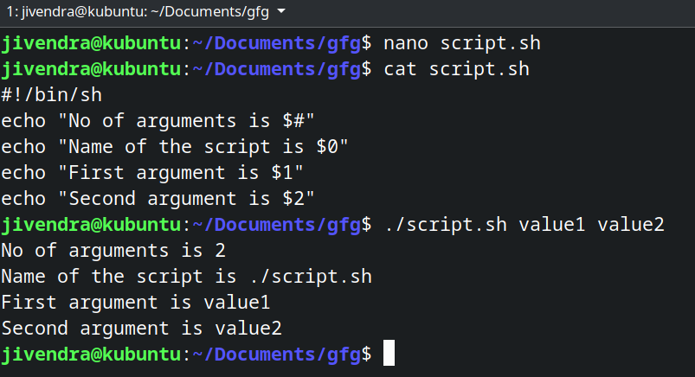

## Storing the output of commands:

You can store the output of commands inside a variable in a shell script. There are two ways to do so.

|  |  |
| --- | --- |
| **Syntax:** | **Example.** |
| **#Syntax 1**  var=$(a valid linux command)  **#Syntax 2**  var2=`a valid linux command` | #!/bin/sh  b=$(pwd)  c=`pwd`  echo $b  echo $c  d=$(ls /bin | grep bash)  echo $d |

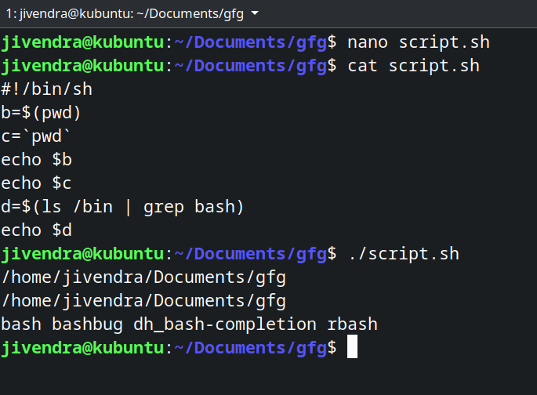

## Exit Codes of shell commands:

## Whenever a command ends and returns the control to the parent process, it returns exit codes between 0 and 255.

## Exit code 0 means the command was successful, and any other exit code means, the command was unsuccessful.

## You can view the exit code after running any command by accessing the #? variable.

* You can manually set an exit code for your shell script. This can be used with conditional statements to convey if the script’s purpose was achieved or not.

**Example:**

#!/bin/sh

read x

if [ $x -ne 10 ]

then

echo failed

exit 1

else

echo passed

exit 0

fi

# **Bash Scripting – Introduction to Bash and Bash Scripting:**

* Bash is a command-line interpreter or Unix Shell and it is widely used in GNU/Linux Operating System.
* Bash scripting is a great way to automate different types of tasks in a system. Developers can avoid doing repetitive tasks using bash scripting.
* Bash scripting supports variables, conditional statements, and loops just like programming languages.

## Applications of Bash Scripts:

* Manipulating files
* Executing routine tasks like Backup operation
* Automation

## Advantages of Bash Scripts:

* It is simple.
* It helps to avoid doing repetitive tasks
* Easy to use
* Frequently performed tasks can be automated
* A sequence of commands can be run as a single command.

### **Disadvantages of Bash Scripts:**

* Any mistake while writing can be costly.
* A new process launched for almost every shell command executed
* Slow execution speed
* Compatibility problems between different platforms

## How to Write Bash Scripts?

* First, we will create a file with the .sh extension.
* Next, we will write down the bash scripts within it
* After that, we will provide execution permission to it.
* To create and write a file with the .sh extension -> gedit scriptname.sh
* The first line of our script file -> #!/bin/bash
* simple script that will print some lines in the terminal -> echo "Hello, GeeksforGeeks"
* save the file and provide the execution permission to it -> chmod +x scriptname.sh
* execute the following script -> ./scriptname.sh

## Input and Output

echo "Enter filename"

read filename

if [ -e $filename ]

then

echo "$filename is exits on the directory"

cat $filename

else

cat > $filename

echo "File created"

fi

**Output of Input & Output:**

**First time:**

Enter filename

geeks.txt

Hello Geek

File created

**Second time:**

Enter filename

geeks.txt

geeks.txt is exits on the directory

Hello Geek

## Functions:

## A function is a block of code that performs some tasks and it can be called multiple times for performing tasks.

## Syntax:

**#for defining**

function_name()

{

commands

.....

}

**# for calling**

function_name

**Example Script:**

#!/bin/bash

**#It is a function**

myFunction () {

echo Hello World from GeeksforGeeks

}

**#function call**

myFunction

**Output of Functions:**

Hello World from GeeksforGeeks

## Decision Making

The programmer provides one or more conditions for the execution of a block of code. If the conditions are satisfied then those block of codes only gets executed.

Two types of decision-making statements are used within shell scripting. They are –

### **If-else statement:**

If else statement is a conditional statement. It can be used to execute two different codes based on whether the given condition is satisfied or not.

There are a couple of varieties present within the if-else statement. They are –

* if-fi
* if-else-fi
* if-elif-else-fi
* nested if-else

|  |  |
| --- | --- |
| **Syntax** | **Example** |
| if [ expression ]; then  statements  fi | Name="Satyajit"  if [ "$Name" = "Satyajit" ]; then  echo "His name is Satyajit. It is true."  fi  **output:**  His name is Satyajit. It is true. |

### **case-sac statement:**

case-sac is basically working the same as switch statement in programming. Sometimes if we have to check multiple conditions, then it may get complicated using if statements.

|  |  |
| --- | --- |
| Syntax | Example |
| case $var in  Pattern 1) Statement 1;;  Pattern n) Statement n;;  esac | Name="Satyajit"  case "$Name" in  **#case 1**  "Rajib") echo "Profession : Software Engineer" ;;  **#case 2**  "Vikas") echo "Profession : Web Developer" ;;  **#case 3**  "Satyajit") echo "Profession : Technical Content Writer" ;;  esac  **output:**  Profession : Technical Content Writer |

## String and Numeric Comparisons

The string comparison means in the shell scripting we can take decisions by doing comparisons within strings as well.

| **Operator** | **Description** |
| --- | --- |
| == | Returns true if the strings are equal |
| != | Returns true if the strings are not equal |
| -n | Returns true if the string to be tested is not null |
| -z | Returns true if the string to be tested is null |

Arithmetic operators are used for checking the arithmetic-based conditions. Like less than, greater than, equals to, etc.

| **Operator** | **Description** |
| --- | --- |
| -eq | Equal |
| -ge | Greater Than or Equal |
| -gt | Greater Than |
| -le | Less Than or Equal |
| -lt | Less Than |
| -ne | Not Equal |

**Example Script:**

if [ 10 -eq 10 ];then

echo "Equal"

fi

if [ 'Geeks' == 'Geeks' ];

then

echo "same" #output

else

echo "not same"

fi

**Output of String and Numeric Comparisons:**

Equal

same